Our task to classify a video into different classes based on its title and description using Naive Bayes technique and analyzing their performance.

These classes are chosen to be:

* Travel Blogs
* Science and Technology
* Food
* Manufacturing
* History
* Art and Music

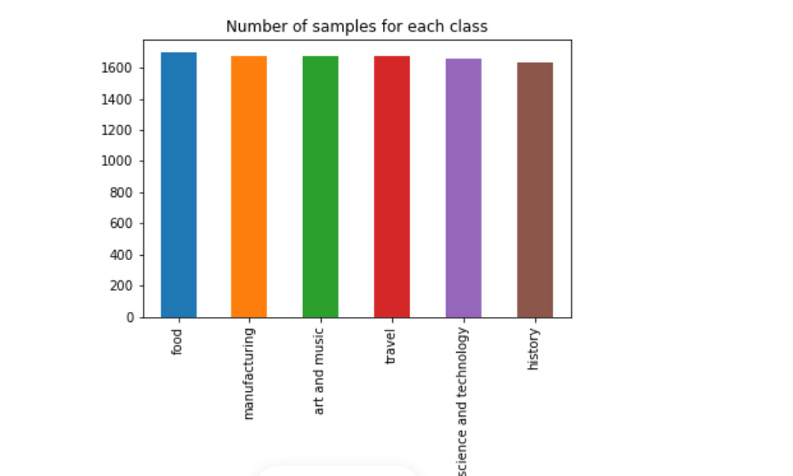

Algorithm and steps involved in code:

* **Data Cleaning and Pre-processing.**

## Data Analysis and Feature Exploration.

## Modeling and Training(Using Naïve Bayes) .

* **Performance evaluation(Using Confusion matrix).**

